**Directions**: *Gobble, gobble, gobble. Color the turkeys. Be as creative as you can!*

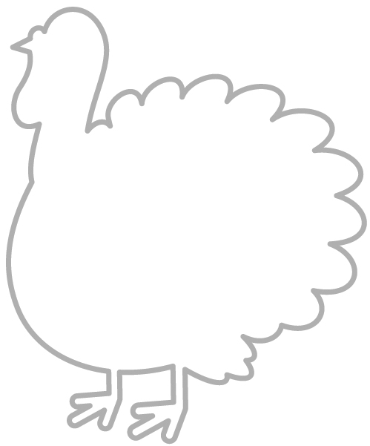



















**Name:**

**Date:**

***Thanksgiving Coloring Page***